**PROGRAM NO-11**

**Aim:** Write a program to implement AND logic functions.

**Code:**

import numpy as np

x=np.array([[1,1],[1,0],[0,1],[0,0]])

t=np.array([[1],[0],[0],[0]])

w=np.array([[0],[0]])

theta=1

yin=np.zeros(shape=(4,1))

y=np.zeros(shape=(4,1))

yin=np.dot(x,w)

i=0

found=0

while(found==0):

i=0

yin=np.dot(x,w)

#print(yin)

while(i<4):

if yin[i]>=theta:

y[i]=1

i=i+1

else:

y[i]=0

i=i+1

#print("y",y)

#print("t",t)

if (y==t).all():

print("MODEL IS TRAINED ")

print("\nOutput : \n",y)

print("\nweights : ",w,"\n")

print("theta : ",theta)

found=1

else:

print("MODEL IS NOT TRAINED")

w=np.zeros(shape=(0,0))

theta=int(input("Enter New Theta : "))

for k in range(int(2)):

w1=int(input("Enter Weight : "))

w=np.append(w,w1)

**Output:**

**Code:**

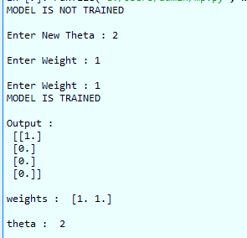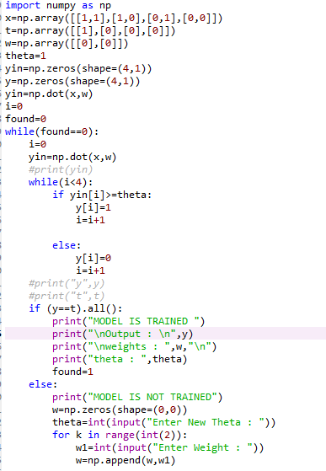

**PROGRAM NO-12**

**Aim:** Write a program to implement OR logic functions.

**Code:**

import numpy as np

x=np.array([[1,1],[1,0],[0,1],[0,0]])

t=np.array([[1],[1],[1],[0]])

w=np.array([[0],[0]])

theta=1

yin=np.zeros(shape=(4,1))

y=np.zeros(shape=(4,1))

yin=np.dot(x,w)

i=0

found=0

while(found==0):

i=0

yin=np.dot(x,w)

#print(yin)

while(i<4):

if yin[i]>=theta:

y[i]=1

i=i+1

else:

y[i]=0

i=i+1

#print("y",y)

#print("t",t)

if (y==t).all():

print("MODEL IS TRAINED ")

print("\nOutput : \n",y)

print("\nweights : ",w,"\n")

print("theta : ",theta)

found=1

else:

print("MODEL IS NOT TRAINED")

w=np.zeros(shape=(0,0))

theta=int(input("Enter New Theta : "))

for k in range(int(2)):

w1=int(input("Enter Weight : "))

w=np.append(w,w1)

Code:

Output:

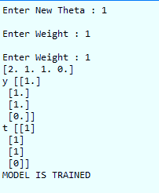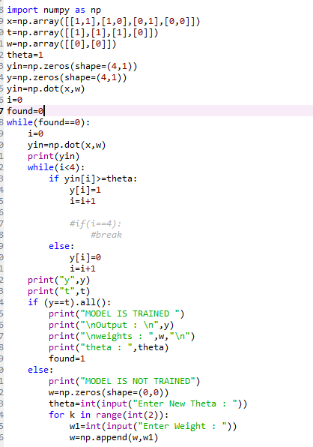

**PROGRAM NO-13**

**Aim:** Write a program to implement AND-NOT logic functions.

**Code:**

import numpy as np

x=np.array([[1,1],[1,0],[0,1],[0,0]])

t=np.array([[0],[1],[0],[0]])

w=np.array([[0],[0]])

theta=1

yin=np.zeros(shape=(4,1))

y=np.zeros(shape=(4,1))

yin=np.dot(x,w)

i=0

found=0

while(found==0):

i=0

yin=np.dot(x,w)

#print(yin)

while(i<4):

if yin[i]>=theta:

y[i]=1

i=i+1

else:

y[i]=0

i=i+1

#print("y",y)

#print("t",t)

if (y==t).all():

print("MODEL IS TRAINED ")

print("\nOutput : \n",y)

print("\nweights : ",w,"\n")

print("theta : ",theta)

found=1

else:

print("MODEL IS NOT TRAINED")

w=np.zeros(shape=(0,0))

theta=int(input("Enter New Theta : "))

for k in range(int(2)):

w1=int(input("Enter Weight : "))

w=np.append(w,w1)

Code:

Output:

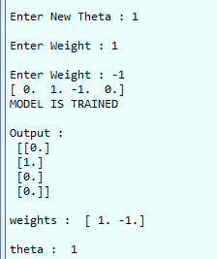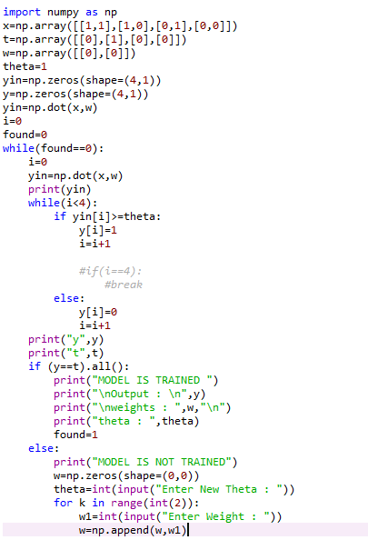

**PROGRAM NO-14**

**Aim:** Write a program to implement NOT logic functions.

**Code:**

import numpy as np

x=np.array([[0],[1]])

t=np.array([[1],[0]])

w=np.array([0])

theta=1

yin=np.zeros(shape=(2,1))

y=np.zeros(shape=(2,1))

yin=np.dot(x,w)

i=0

found=0

while(found==0):

i=0

yin=np.dot(x,w)

print(yin)

while(i<2):

if yin[i]>=theta:

y[i]=1

i=i+1

#if(i==4):

#break

else:

y[i]=0

i=i+1

print("y",y)

print("t",t)

if (y==t).all():

print("MODEL IS TRAINED ")

print("\nOutput : \n",y)

print("\nweights : ",w,"\n")

print("theta : ",theta)

found=1

else:

print("MODEL IS NOT TRAINED")

w=np.zeros(shape=(0,0))

theta=int(input("Enter New Theta : "))

for k in range(int(1)):

w=int(input("Enter Weight : "))

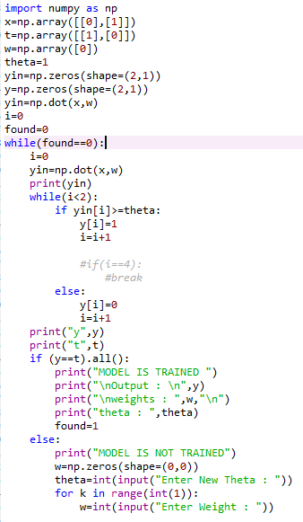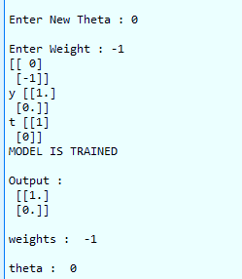Code:

Output: